Program: 01

Date:

**SUM AND AVERAGE**

**AIM:** Write a program to find sum and average of set of numbers.

**PROGRAM:**

s=0

n=int(input("Enter limit : "))

print("Enter elements : ")

for i in range(0,n):

g=int(input())

s = s + g

print("sum = ",s)

average=s/n

print("average = ",average)

**RESULT:**

Program executed successfully

**OUTPUT:**

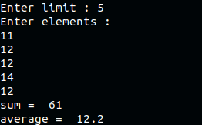

Program: 02

Date:

**IDENTIFY NUMBERS**

**AIM:** Write a program to identify Prime number, Armstrong number, Perfect number and Fibonacci numbers.

**PROGRAM:**

a=0

while a==0:

print("1:prime or not 2:fibnocci 3:armstrong 4:perfect number 5:exit")

p=int(input("enter your option : "))

if(p==1):

num=int(input("enter the number : "))

flag=False

if num>1:

for i in range(2,num):

if(num%i)==0:

flag=True

break

if flag:

print(num,"is not a prime number")

else:

print(num,"is a prime number")

if(p==2):

nterms=int(input("how many numbers : "))

n1,n2=0,1

count=0

if nterms<=0:

print("please enter a positive integer : ")

elif nterms==1:

print("fibonacci sequence upto",nterms,":")

print(n1)

else:

print("fibonacci sequence : ")

while count<nterms:

print(n1)

nth=n1+n2

n1=n2

n2=nth

count+=1

if(p==3):

num=int(input("enter a number : "))

sum=0

temp=num

while temp>0:

digit=temp%10

sum +=digit**3

temp//=10

if num==sum:

print(num,"is an armstrong number")

else:

print(num,"is not an armstrong")

if(p==4):

n=int(input("enter a number : "))

sum1=0

for i in range(1,n):

if(n%i==0):

sum1=sum1+i

if(sum1==n):

print("the number is a perfect number")

else:

print("the number is not a perfect number")

if(p==5):

a=1

**RESULT:**

Program executed successfully

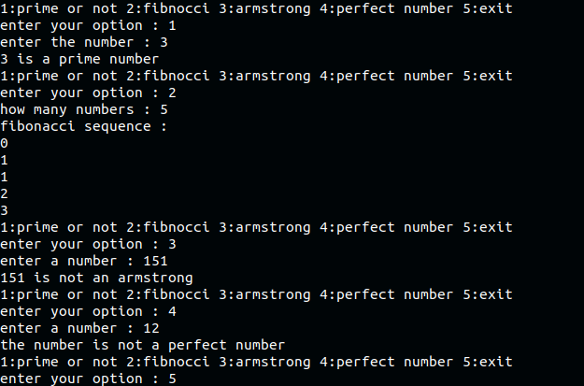**OUTPUT:**

Program: 03

Date:

**REPLACE STRING**

**AIM:** Develop a python program to accept a text string “hello student welcome to mes aimat give your details” & replace the word “student” in the text with the name accepted from the user

**PROGRAM:**

string = input("***hello student welcome to mes aimat give your details***")

str=input("Enter your name : ")

print(string.replace("student", str))

**RESULT:**

Program executed successfully

**OUTPUT:**



Program: 04

Date:

**LEAP YEAR**

**AIM:** Write a program to read a year (4-digit integer) and tell whether the given year is / was a leap year.

**PROGRAM:**

Year = int(input("Enter the year: "))

def CheckLeap(Year):

if((Year % 400 == 0) or

(Year % 100 != 0) and

(Year % 4 == 0)):

print(Year," is a leap Year");

else:

print (Year," is not a leap Year");

CheckLeap(Year)

**RESULT:**

Program executed successfully

**OUTPUT:**





Program: 05

Date:

**ODD AND EVEN SUM**

**AIM:** Write a program to find odd and even sum of an integer.

**PROGRAM:**

NumList=[]

evenSum=0

oddSum=0

Number=int(input("Enter the limit of the list : "))

print("Enter the elemets : ")

for i in range(1, Number+1):

value=int(input())

NumList.append(value)

for j in range(Number):

if(NumList[j]%2==0):

evenSum=evenSum+NumList[j]

else:

oddSum=oddSum+NumList[j]

print("\nThe sum of even numbers in the list= ",evenSum)

print("\nThe sum of odd numbers in the list= ",oddSum)

**RESULT:**

Program executed successfully

**OUTPUT:**

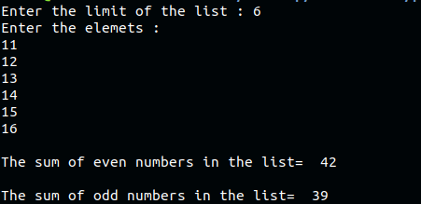

Program: 06

Date:

**STRING FUNCTIONS**

**AIM:** Write a program to find vowel, consonants, digit, special characters in a string.

**PROGRAM:**

vowels = 0

consonant = 0

specialChar = 0

digit = 0

str=input("Enter a string : ")

for i in range(0, len(str)):

ch = str[i]

if ( (ch >= 'a' and ch <= 'z') or

(ch >= 'A' and ch <= 'Z') ):

ch = ch.lower()

if (ch == 'a' or ch == 'e' or ch == 'i' or ch == 'o' or ch == 'u'):

vowels += 1

else:

consonant += 1

elif (ch >= '0' and ch <= '9'):

digit += 1

else:

specialChar += 1

print("string :", str)

print("Vowels:", vowels)

print("Consonant:", consonant)

print("Digit:", digit)

print("Special Character:", specialChar)

**RESULT:**

Program executed successfully

**OUTPUT:**

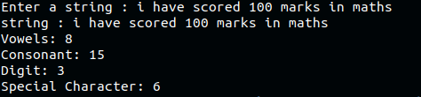

Program: 07

Date:

**THREE DIGIT COMBINATIONS**

**AIM:** Demonstrate 3-digit combination in python

**PROGRAM:**

first_num = int(input("Enter the first number:"))

second_num = int(input("Enter the second number:"))

third_num = int(input("Enter the third number:"))

my_list = []

print("The first number is ")

print(first_num)

print("The second number is ")

print(second_num)

print("The third number is ")

print(third_num)

my_list.append(first_num)

my_list.append(second_num)

my_list.append(third_num)

for i in range(0,3):

for j in range(0,3):

for k in range(0,3):

if(i!=j&j!=k&k!=i):

print(my_list[i],my_list[j],my_list[k])

**RESULT:**

Program executed successfully

**OUTPUT:**

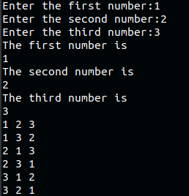

Program: 08

Date:

**MARK GRADING**

**AIM:** Write a program to enter name and degree of students and give the grade according to the mark.

**PROGRAM:**

n=int(input("enter the number of students:"))

a=0

total=0

avg=0

while a!=n:

n = n-1

name=input("enter student name:")

degree=input("enter student degree:")

mark1=int(input("enter mark1:"))

mark2=int(input("enter mark2:"))

mark3=int(input("enter mark3:"))

total=mark1+mark2+mark3

avg=total//3

if(avg >= 90):

print("student name:",name)

print("student degree:",degree)

print("grade: A+ ")

elif(avg >=80):

print("student name:",name)

print("student degree:",degree)

print("grade: A ")

elif(avg >=870):

print("student name:",name)

print("student degree:",degree)

print("grade: B+ ")

elif(avg >=60):

print("student name:",name)

print("student degree:",degree)

print("grade: B ")

elif(avg >=50):

print("student name:",name)

print("student degree:",degree)

print("grade: C+ ")

elif(avg >=40):

print("student name:",name)

print("student degree:",degree)

print("grade: C ")

else:

print("FAILED")

**RESULT:**

Program executed successfully

**OUTPUT:**

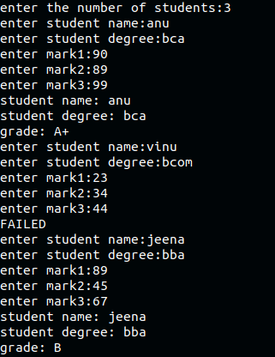

Program: 09

Date:

**IF OPERATION**

**AIM:** Write a program to print current bill using if operation

**PROGRAM:**

units=int(input("please enter the number of units you consumed in a month"))

if(units<=100):

payAmount=units*1.5

fixedcharge=25.00

elif(units<=200):

payAmount=(100*1.5)+(units-100)*2.5

fixedcharge=50.00

elif(units<=300):

payAmount=(100*1.5)+(200-100)*2.5+(units-200)*4

fixedcharge=75.00

elif(units<=350):

payAmount=(100*1.5)+(200-100)*2.5+(300-200)*4+(units-300)*5

fixedcharge=100.00

else:

payAmount=0

fixedcharge=1500.00

Total=payAmount+fixedcharge;

print("\nElecticity bill=%.2f" %Total)

**RESULT:**

Program executed successfully

**OUTPUT:**

Program: 10

Date:

**TUPLE AND LIST**

**AIM:** Write a program to implement student record processing with tuple and list application

**PROGRAM:**

listid=[]

listname=[]

listcourse=[]

listmark=[]

listtotal=[]

liststu=[]

mark=()

n=int(input("Enter the limit of students"))

for i in range(n):

s_id=int(input("Enter id:"))

listid.append(s_id)

liststu.extend(listid)

listid=[]

name=input("Enter Name:")

listname.append(name)

liststu.extend(listname)

listname=[]

course=input("Enter Course:")

listcourse.append(course)

liststu.extend(listcourse)

listcourse=[]

print("Enter 3 Marks")

m1=int(input())

m2=int(input())

m3=int(input())

total=m1+m2+m3

mark=(m1,m2,m3)

listmark.append(mark)

liststu.extend(listmark)

listtotal.append(total)

#liststu.extend(listtotal)

listmark=[]

max_list=max(listtotal)

print(listtotal)

temp_mark = 0;

index_of_super_student = 0;

for i in range(len(listtotal)):

if (listtotal[i] > temp_mark):

temp_mark = listtotal[i]

index_of_super_student = i;

print('Student ID:', liststu)

test_index_cnt = 0;

for i in range(len(liststu)):

if((i+1)%4):

ab = 'bla'

else:

if(4*(index_of_super_student+1) == i+1):

print('Student_ID: ', liststu[i-3])

print('Student_NAME: ', liststu[i-2])

print('Student_COURSE: ', liststu[i-1])

print('Student_MARK: ', liststu[i-4])

print("Great Mark", temp_mark)

**RESULT:**

Program executed successfully

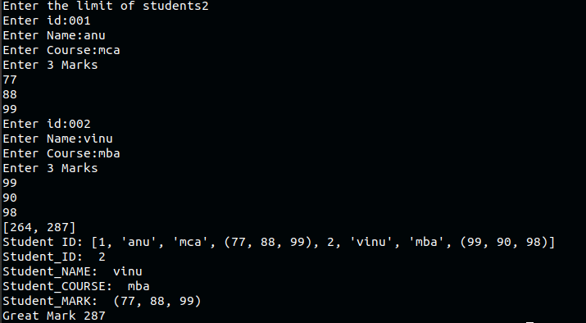**OUTPUT:**

Program: 11

Date:

**SET OPERATIONS**

**AIM:** Write a program to implement 4 set operations.

**PROGRAM:**

E = {0, 2, 4, 6, 8};

N = {1, 2, 3, 4, 5};

print("Set E =",E)

print("Set N =",N)

print("Union of E and N is",E | N)

print("Intersection of E and N is",E & N)

print("Difference of E and N is",E - N)

print("Symmetric difference of E and N is",E ^ N)

**RESULT:**

Program executed successfully

**OUTPUT:**

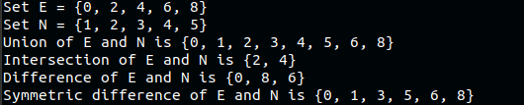

Program: 12

Date:

**DICTIONARY**

**AIM:** Write a program to implement dictionary (create, add item, remove item, modify item)

**PROGRAM:**

my_dict={"Name":[],"age":[],"salary":[],"Year":[]}

print(my_dict)

a=0

while(a==0):

print("\n Menu\n1.add\n2.remove\n3.update")

s=int(input("\nenter your choice:"))

if s==1 :

name=input("enter the name : ")

age=int(input("enter the age : "))

salary=int(input("enter salary : "))

year=int(input("enter joining date : "))

my_dict["Name"].append(name)

my_dict["age"].append(age)

my_dict["salary"].append(salary)

my_dict["Year"].append(year)

print(my_dict)

if s==2:

my_dict.pop("Year")

print(my_dict)

if s==3:

new_name=input("enter new name : ")

new_age=int(input("enter new age : "))

new_salary=int(input("enter new salary : "))

my_dict["Name"]=new_name

my_dict["age"]=new_age

my_dict["salary"]=new_salary

print(my_dict)

a=int(input("\ndo you want to continue? press 0 for yes, otherwise not : "))

**RESULT:**

Program executed successfully

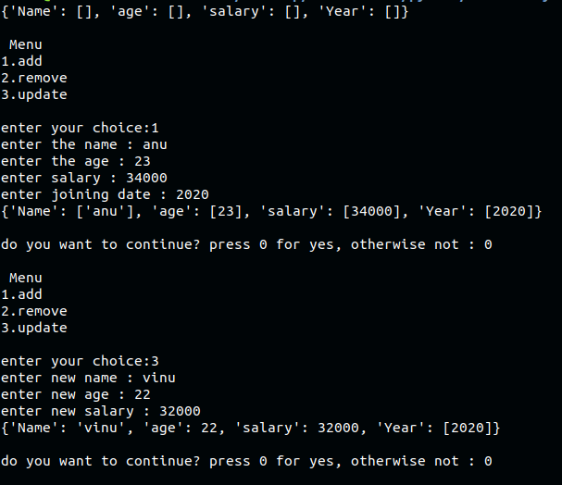**OUTPUT:**

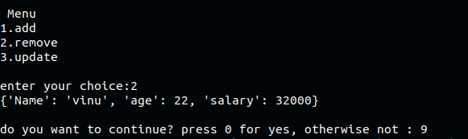

Program: 13

Date:

**USER DEFINED FUNCTION**

**AIM:** Write a program to implement a user defined function for calculating mean, median, mode

**PROGRAM:**

def find_mean(numbers):

return sum(numbers)/len(numbers)

def find_median(numbers):

if len(numbers)%2 == 0:

return (numbers[(len(numbers)-1)//2] + numbers[(len(numbers)+1)//2])/2

return numbers[len(numbers)//2]

def count_frequency(numbers, number):

frequency = 0

for i in range(len(numbers)):

if numbers[i] == number:

frequency += 1

return frequency

def find_max_frequency(frequencies):

return max(frequencies)

def find_modes(numbers):

frequencies = []

for number in numbers:

frequency = count_frequency(numbers, number)

frequencies.append(frequency)

max_frequency = find_max_frequency(frequencies)

modes = []

for number in numbers:

frequency = count_frequency(numbers, number)

if frequency == max_frequency and number not in modes:

modes.append(number)

return modes

numbers = []

n = int(input("Enter the limit : "))

for i in range(1, n + 1):

value = int(input("Enter the Value of %d Element : " %i))

numbers.append(value)

numbers.sort()

mean = find_mean(numbers)

median = find_median(numbers)

modes = find_modes(numbers)

print("Mean: ", round(mean,2))

print("Median: ", median)

print("Mode: ", end='')

for mode in modes:

print(mode, end=" ")

print("\n")

**RESULT:**

Program executed successfully

**OUTPUT:**

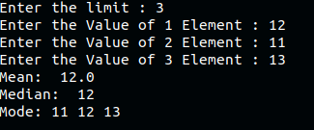

Program: 14

Date:

**TEXT AS ARGUMENT**

**AIM:** Write a function which takes text as argument and calculate

a. Calculate how many words starts with letter ‘t’.

b. Calculate how many words ends with the letter ‘s’.

c. Calculate how many 6 letters words are appearing.

d. Calculates how many words are there in the given text.

**PROGRAM:**

def letters(n):

s=n

t=0

sc=0

l=[]

s = s.split(' ')

n=n.split()

for word in s:

if(word.startswith("t")):

t=t+1

if(word.endswith("s")):

sc=sc+1

if(len(word)==6):

l.append(word)

print("The no of words in the string is:",len(n))

print("Number of words starts with letter ‘t’:",t)

print("Number of words ends with letter ‘s’:",sc)

print("6 letters words appearing are : ",l)

n=input("Enter the string:")

letters(n)

**RESULT:**

Program executed successfully

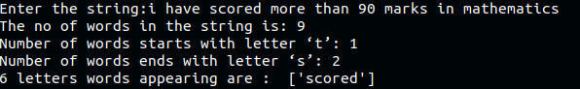**OUTPUT:**

Program: 15

Date:

**AREA AND PERIMETER**

**AIM:** Write a function to find out the area and perimeter of rectangle and circle.

**PROGRAM:**

l=int(input("enter length of rectangle"))

b=int(input("enter breadth of rectangle"))

def area(l,b):

return(l*b)

def perimeter(l,b):

return(2*(l+b))

print("area of rectangle is",area(l,b))

print("perimeter of rectangle is",perimeter(l,b))

r=int(input("enter radius of circle"))

def carea(r):

return(3.14*r*r)

def cperimeter(r):

return(2*3.14*r)

print("area of circle is",carea(r))

print("perimeter of circle is",cperimeter(r))

**RESULT:**

Program executed successfully

**OUTPUT:**

